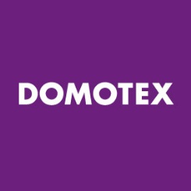

Request for press pass for
DOMOTEX 2018 (12 to 15 January)

Please complete this form in full and return it by post, fax, or e-mail by no later than
15 December 2017 to Deutsche Messe, Press and Public Relations, Claudia Eckardt, Messegelände, 30521 Hannover, Germany, Fax: +49 511 89 34013, Email: claudia.eckardt@messe.de

Please remember to provide verification of your journalistic credentials (e.g. a copy of your press ID, a copy of your publication etc.) when submitting this form.

First and last name: _________________________________________________________

Publication: _______________________________________________________________

Address/P.O.Box:___________________________________________________________

City, Postcode:_____________________________________________________________

State/Country: _____________________________________________________________

Telephone.: (______) - _______________ Fax: (______) - __________________________

Email:____________________________________________________________________

Date of birth: ______________________________________________________________

Mobile no.:________________________________________________________________

(If you would like exhibitors to be able to contact you at the Exhibition Grounds, please include your mobile/cell number. We will make these numbers available to exhibitors on request only.)

I require a parking permit for a car O Yes O No

Field: O Trade press O Daily/Business Newspaper
O Radio O Television
O Popular Press O Company Publication
O Trade Association Press O Youth Press
O Online Media O Analyst
O BLOG

I hereby grant permission to Deutsche Messe AG to forward my contact details to third-party organizers of events hosted by Deutsche Messe AG and/or to exhibitors participating in Deutsche Messe events and/or to companies participating in said events. I understand that this permission is being granted solely for the purpose of enabling the above-mentioned parties to provide me with information pertinent to trade fairs.

O Yes O No

If you have any questions or concerns regarding the use of your data or your permission to grant use thereof, please contact Claudia Eckardt at claudia.eckardt@messe.de.

