Press release
Hannover, June 2019

“ATMYSPHERE”: Keynote theme for DOMOTEX 2020 –
Products from participating exhibitors as a basis for outdoor projects promoting wellbeing

- Architecture and design concepts are increasingly shaped by health, naturalness and sustainability
- Manufacturers are invited to creatively stage their products as expressions of the keynote theme

The keynote theme for the 2020 edition of DOMOTEX, the world’s leading trade show for carpets and floor coverings, is “ATMYSPHERE”. The show, which runs from 10 to 13 January 2020 in Hannover, Germany, will thus have as its central focus all those qualities of floors and floor coverings that contribute to wellbeing and accentuate naturalness and sustainability.

Health and wellness are a major social trend at present, and for many people that means spending plenty of their leisure time outdoors in natural settings. On sunny days, patios, decks, balconies and gardens double as lovingly designed, lifestyle-enhancing outdoor extensions of indoor living spaces. The same holds true in the contract flooring sector. Society’s growing awareness of health and wellness translates into heightened expectations in terms of the visual aesthetics, quality and characteristics of outdoor flooring products – whether in the home or in hotels, restaurants and outdoor areas of showrooms.

It is with these trends firmly in mind that the companies exhibiting at DOMOTEX are increasingly developing high-quality flooring made of natural wood, innovative planks made of WPC, and tiles that are suitable for both indoor and outdoor use. The sheer range of the products available provides a richly diverse and creative design palette for home owners and contract flooring professionals. Architects and interior designers use the products showcased by exhibitors at DOMOTEX to create fluid transitions between indoor and outdoor spaces. By connecting otherwise disparate functional areas, these products create unique spaces that contribute directly to the wellbeing of the people who live and work in them. Following is a selection of exhibitor projects which exemplify this.
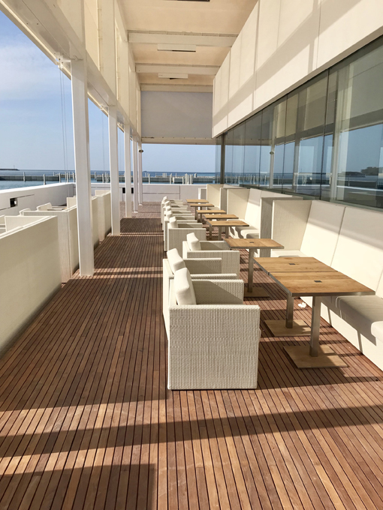
The Louvre Abu Dhabi is world-renowned architect Jean Nouvel’s most spectacular creation so far and has won widespread international acclaim. The museum’s defining feature is its roofline – a modern interpretation of the classic Arabic dome. A slivery lattice of complex geometric patterns, the dome filters sunlight to create a constantly changing “rain of light” on the building’s flooring. For the outdoor area of the museum’s waterfront café, Ateliers Jean Nouvel partnered with the design team of DOMOTEX exhibitor YVYRA to develop “Exterpark Louvre”, an exquisite teak decking timber that is installed using an ingenious system of magnetic clips. The planks are inspired by the decking used on luxury boats. The individual timbers are only 57 mm wide and are designed to be installed without visible gaps or screws in mere seconds. They are simply clipped on to an aluminum substructure using a special tool. The planks work together to create a unified, extremely elegant outdoor floorscape. The individual timbers are quick to install and can be removed for redeployment or replacement with consummate ease at any time, according to YVYRA Export Director Mario Rodríguez, who worked closely with Ateliers Jean Nouvel in the development of the custom-designed teak decking system.

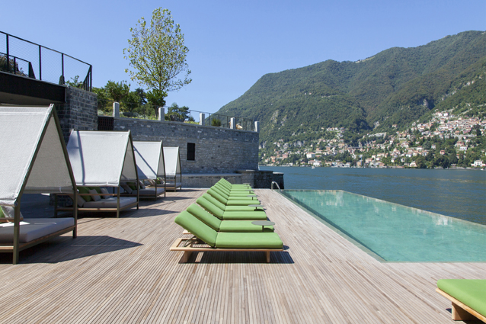
On the eastern shore of Italy’s Lake Como, the Milan-based Spanish-born architect and designer Patricia Urquiola has created Il Sereno, a contemporary-style luxury hotel that evinces loving attention to detail in absolutely every respect. Every aspect of the hotel, from its private boats to its fit-out and furnishings, has been custom-designed to complement the location’s stunning natural environment. A private jetty connects the lake with the hotel complex, which is set against the backdrop of the Italian Alps. The outdoor area of Il Sereno features vertical botanical gardens, and the restaurant adjoining the gardens is open on one side, while the flooring design creates seamless indoor-outdoor flow. For the outdoor floorings, Urquiola used thermo-treated FSC-certified ash decking custom-created by DOMOTEX exhibitor Ravaioli Legnami and installed in cooperation with the company Pavilegno. The decking planks are very narrow and have a special concealed milling – characteristics that create a vibrant and unique visual aesthetic.

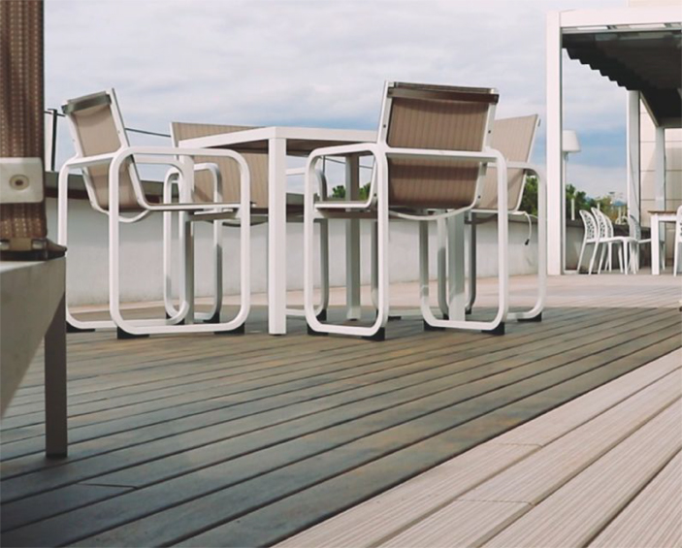
At DOMOTEX 2019, Switzerland’s Li&Co presented their new LICO Outex Design outdoor flooring. Outex Design is a wood-look decking product comprising a non-slip, easy-care and weather-resistant synthetic pattern layer laminated onto thermo-treated pine planking. It was first shown to the public on the deck of flooring company Floover’s showroom in Barcelona. Floover uses the showroom for prestige events, such as receptions for customers and architects. Floover has a joint venture with Li&Co and sells its contract flooring products worldwide. “The new decking design gives us a solution for decks that boasts a similarly realistic wood look as the laminated products used indoors,” said Floover Sales Manager Jérôme Gaubert. It is ideal, he said, for customers who want to create a quality visual connection between their indoor and outdoor areas. “The new decking design by Li&Co is UV-resistant and extremely hard-wearing, so it is also suitable for commercial use. It is pleasant to the touch, even on hot, barefoot days at the height of summer.”

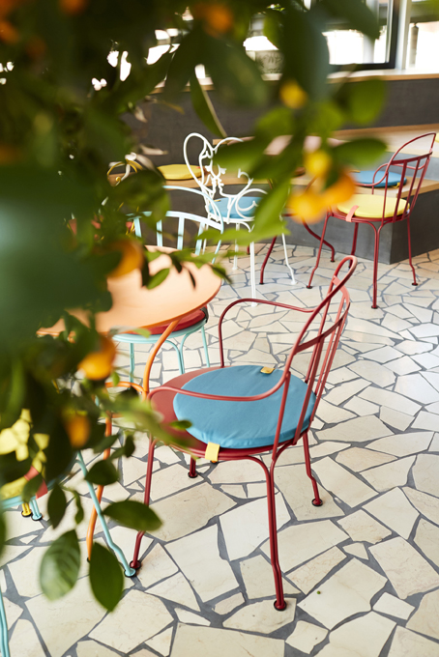
Hamburg-based architect Julia Erdmann is a regular DOMOTEX visitor and believes in creating spaces that are relaxing, enjoyable places to be in. For the gourmet restaurant “Bianc” and adjoining bar “Picnic” owned and operated by star chef Matteo Ferrantino in the Am Sandtorpark neighborhood of Hamburg’s prestigious HafenCity precinct Erdmann created a space with a truly warm, inviting atmosphere. “The aim was give diners the feeling that they’re spending the evening somewhere in the Mediterranean region,” explained Erdmann. The result is both a new culinary destination and a portal to world of Mediterranean charm, where guests can dine in a piazza setting beneath an olive tree canopy. With its loving attention to detail, the design of the restaurant is reminiscent both of southern Italy’s Apulia region and Portugal – the two locations that have most influenced Ferrantino’s Mediterranean cuisine. For the interior, Erdmann used outdoor flooring to enhance the al fresco feel that is fundamental to the restaurant’s design. The “Biancone” natural-stone outdoor tiles have been specially treated so that they are equal to all the demands and requirements of indoor use. As in Apulia, where the chef is from, the tiles have been laid with wide joints and rough edges.
Used indoors, outdoor flooring is a highly effective way of creating a unique atmosphere, Erdmann believes. “With the right setting and composition, they really do create the feeling – both conscious and subconscious – of being outside.” Even the restrooms have a distinctly Mediterranean feel and feature outdoor materials. Anyone who has been to Barcelona will know the Gaudi relief-pattern cement tiles on the city’s pavements. Erdmann used the same type of tiling for the design of the restrooms. For her, creating office spaces, restaurants and hotel lobbies that make users feel close to nature and maximize their sense of wellbeing is no mere passing trend. A key part of her approach lies in intelligently creating connections and transitions between indoor and outdoor spaces – hence the great importance she attaches to using flooring products that work well on both sides of the indoor-outdoor transition. In terms of the current market offering, Erdmann notes that “there is still ample scope for innovative materials.”

The latest developments in outdoor flooring will be on show at DOMOTEX, which runs from 10 to 13 January 2020. Here, innovative manufacturers will showcase a richly diverse range of flooring solutions inspired by the keynote theme, ATMYSPHERE.

DOMOTEX 2020
10–13 January (Friday–Monday)
Hannover Exhibition Center (Hannover, Germany)
www.domotex.de

DOMOTEX press contact  neumann communication  Stephanie Klein and Hannah Knospe  phone: +49 (0) 221 913949-0  E-Mail: domotex@neumann-communication.de | DOMOTEX team contact  Marketing & Communications  Anna Gerhard  phone: +49 (0) 511 8931603  E-Mail: anna.gerhard@messe.de

