Press Release
Hannover, April 2019

ATMYSPHERE as the keynote theme for DOMOTEX 2020:

- Inspired by the health megatrend, the keynote theme for DOMOTEX puts wellbeing, naturalness and sustainability at the top of the agenda
- Stronger focus on contract business
- Manufacturers invited to creatively frame their products as expressions of the keynote theme

After a successful DOMOTEX 2019, preparations are already ramping up for the 2020 edition of the world’s leading trade show for carpets and floor coverings. The upcoming show, to be held from 10 to 13 January 2020, has ATMYSPHERE as its keynote theme, symbolizing its central focus on all those qualities of floors and floor coverings that contribute to wellbeing, naturalness and sustainability.

Examples of products from the floor coverings industry that possess these qualities include floors with acoustic properties or sound-insulation components; carpets that bind fine dust particles or have thermal insulation properties; resilient floor coverings that are hypo-allergenic; and natural-wood floorboards that improve the interior climate by capturing excess humidity and releasing it again when the air in the room is dry. Other qualities that enhance positive indoor atmospherics include softness and pleasantness to the touch, sustainability, and aesthetic details that help transform rooms into oases of personal wellbeing.

“This year, as indeed in previous years, the lead theme is inspired by a current megatrend,” explains Sonia Wedell-Castellano, Deutsche Messe’s Global Director DOMOTEX. “And that trend is society’s heightened focus on health. Health is synonymous with quality of life and living well – and therefore translates into high expectations of the spaces around us. Alongside this, considerations of sustainability and recycling – and hence natural materials – continue to play a major role in our society. In terms of floor coverings, these are considerations and themes that are currently very much to the fore with our exhibitors and their work, especially given the great importance of floors as elements of creative interior design. With the right materials and design, carpets and floor coverings can be important factors in personal wellbeing and in the design of homes and workplaces that promote it. That is why ATMYSPHERE is of such definitive importance for all our exhibitors and visitor target groups.”

Products for perfect interior atmospheres

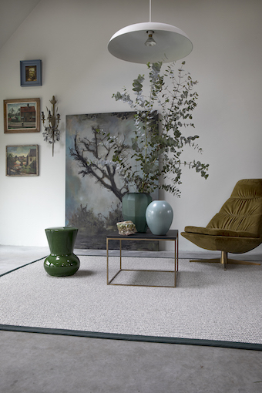
The “Monasch by Best Wool” collection by Best Wool Carpets comprises sumptuously soft and warm rugs made of pure wool in a luxurious array of colors, sizes and fits. It includes “Crayons”, which is available with border trims of linen, felt or leather for that essential element of contrast. With its superior wool quality, this high-comfort rug collection helps to regulate humidity and create a healthy interior climate. It is also sound-absorbing and hypoallergenic. Each rug is fully recyclable, including the backing layer on the reverse.

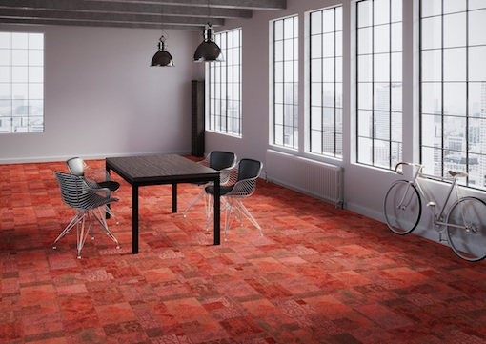
The “Style” collection by Girloon is acoustically absorbent, eco-friendly and can create a whole range of interior atmospheres. A modular system of self-adhesive carpet tiles, it comes in three surface textures and loads of colors and designs. Thanks to the possibilities of digital printing, there is even a variant that customers can personalize. Low-emission and fitted with acoustically absorbent comfort underlay, the tiles are ideal for contract interiors. They are “Blue Angel” eco-certified, can be installed without additional glues and tapes thanks to their innovative self-adhesive backing, and can be laid with no pattern repeat to create the ultimate calming, health-promoting indoor atmosphere.
“LICO Wall Wood” und “LICO Wall Cork” by Li & Co are elegant modular wall coverings made of eco-friendly materials that create a natural room ambience with excellent thermal insulation. The individual modules are quickly and easily installed thanks to their self-adhesive backing, and their noise-reducing properties are enhanced by their decorative, three-dimensional surface structure. The “LICO Wall Hydro Print” system, additionally, delivers the twin benefits of floor-to-ceiling waterproofing and personalized design. Ideal for bathrooms and wellness areas, they are the wet-area solution of choice for renovations and newbuilds alike.

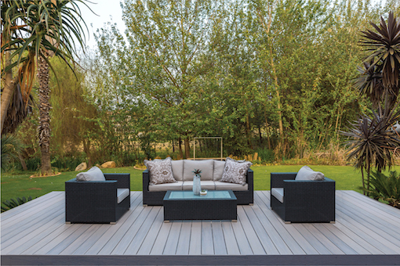
The “Rhinowood Wax Pine” decking products by Ravaioli Legnami are treated using a patented wax-impregnation process, so they are extremely long-lasting and hold their shape, delivering the ultimate in carefree outdoor living. The natural wax treatment preserves the characteristic grain pattern of the sustainably sourced pine while giving the timber the weatherproof properties of hardwoods. As an alternative to natural wood, Ravaioli Legnami offers an attractive range of engineered decking products, including its “WPC Deluxe” wood fiber-plastic composite products, which feature an anti-slip three-dimensional wood grain. Both product lines provide the perfect palette for individualized extension from indoor to outdoor.

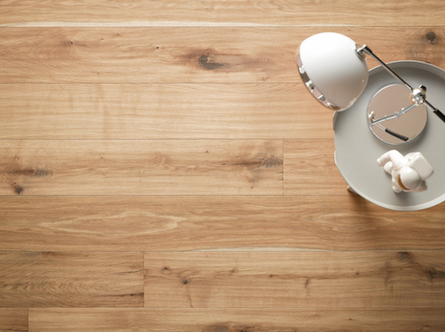
Flooring manufacturer ter Hürne crafts warm, inviting parquet floors from specially selected timbers. Its “Unique” collection of parquet planks is available in three main surface structures – hand-scraped, enhanced-knot and split-oak – that accentuate the wood’s natural characteristics. The planks are treated with certified natural oils to bring out the natural wood colors, resulting in an exquisite collection that comprises 12 distinct variants. The collection is a celebration of natural wood materials, its various elements all working together to create unique floorscapes with an unmistakable aged-wood charm. And like all natural-wood floors, they help create a comfortable indoor climate by regulating humidity.

“Small as this selection is, it shows that our DOMOTEX exhibitors are developing a comprehensive range of products that designers can use to create atmospheres of wellbeing and ideal workplace environments,” says Wedell-Castellano.

Prospective participants invited to apply now with their innovative ideas inspired by “ATMYSPHERE”

The “Framing Trends” showcase at DOMOTEX 2020 is a unique opportunity for manufacturers, artists and students to stage interior designs inspired by the ATMYSPHERE keynote theme and hence position themselves as trend leaders in innovative products and solutions for today’s modern floors and their positive, life-affirming qualities. Applications for participation at the “Framing Trends” showcase are now open. Interested exhibitors and flooring-industry companies are invited to submit their ideas for displays of indoor oases of wellbeing that are built from the floor up. Possible exhibition formats range from walk-through installations inspired by interiors for the contract segment, private homes and the hospitality sector, to interactive spaces that invite participation and the sharing of ideas.

With its stimulating, high-quality program of talks, lectures and discussion panels based on the ATMYSPHERE keynote theme, “Framing Trends” is the beating heart of the DOMOTEX show. It is a forum where creatives from all design-oriented professions can meet up, make new contacts, find inspiration and do business.

The organizers are keen for the show’s exhibitors to get behind ATMYSPHERE and make it happen. “Ideally we would like all exhibitors – whether exhibiting within or outside the ‘Framing Trends’ showcase – to draw inspiration from it and hence base their displays in a meaningful way on our keynote theme,” explains Wedell-Castellano. “That way, ATMYSPHERE will be reflected in all of the exhibition halls, creating the perfect, attractive atmosphere for four busy days of tradeshow action!”

DOMOTEX 2020
10–13 January (Fri.–Mon.)
Hannover Exhibition Center, Germany
www.domotex.de

DOMOTEX press contact  neumann communication  Stephanie Klein and Hannah Knospe  Tel: +49 221 913949-0  E-mail: domotex@neumann-communication.de | Direct DOMOTEX contact  Marketing & Communication  Anna Gerhard  Tel: +49 511 89-31603  E-mail: anna.gerhard@messe.de

