Press release
Hannover, November 2019

WOOD.WORKS – continuing the journey of wood through the dimensions of wellbeing

Second “made in Italy” design showcase to feature at DOMOTEX 2020, reflecting sustainability and the trend towards the use of natural materials

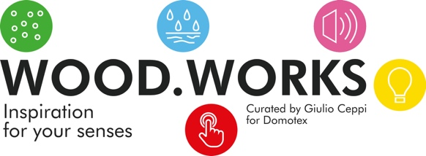
WOOD.WORKS analyzes wood as a vital element in creating a sense of wellbeing for indoor environments. Following the success of the WOOD.LIFECYCLE showcase in Hannover and in Milan in 2019, wood as a material will again feature at the next DOMOTEX, the international flooring show staged in Hannover, Germany, from 10 to 13 January 2020. As part of the special Framing Trends display (this time located in Hall 8), a range of Italian firms, among which Arkimia, Elitis, Materica, Parital, Randa Line, Tabu, WOOD-SKIN, will display their creative products and solutions highlighting the qualities and characteristics of wood, with a specific linkage to the concept of wellbeing. The artistic director will again be the architect Giulio Ceppi, founder of Total Tool Milano, and project management will be in the capable hands of the TE.AM. Group.

Properties and applications of wood to enhance the qualities of indoor environments

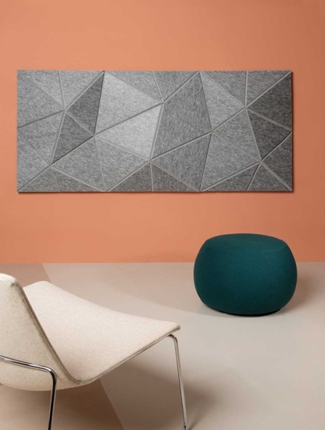
The showcase revolves around five themes: purification, water resistance, acoustic management, use of light and tactile impressions. These will provide the conceptual basis for the participants’ exhibits – which in many cases have been created specifically for the showcase.
The exhibits will highlight the special properties of wood that help to enhance the quality of indoor environments through a range of applications: sound insulation, water resistance, new tactile sensations, and the antibacterial action of wood. The show is a perfect fit with ATMYSPHERE, the keynote theme of DOMOTEX 2020, inspired by the increasing interest in health and wellbeing seen in society today. Our sense of wellbeing is to a very large extent shaped by the quality of our living and working environments, and the furniture and fittings that surround us. The use of natural materials and the recycling of those materials clearly have a fundamental part to play in this context.

Sensory dialogue between wood and its surrounding environment


The guiding hand of Giulio Ceppi is clearly evident in the innovative use of wood as a material, interpreted from a perspective emphasizing its many beneficial characteristics. He believes that “(…) by its very nature, wood is a living, organic material, which has always been linked to the concept of ‘wellbeing’ as it has evolved over time. And today we have new technical opportunities to derive still further enhancements in terms of tactile qualities, water resistance, acoustic management, scented atmospheres, and the interaction with light.”

He is also fascinated by the ways in which wood interacts with its surrounding environment, and its versatility in combining with other materials. “Our showcase will highlight the extent to which wood maintains a sensory conversation with us, in new and unexpected ways, revealing itself more and more as a living, and supremely bio-compatible, material.”

DOMOTEX 2020
10 - 13 January (Friday to Monday)
Hannover Exhibition Center, Hannover/Germany
https://www.domotex.de/home

Hannover Fairs International GmbH  Fiera di Hannover | Sede Italiana  Federica Piccioni, Project Manager  phone: +39 0270633292 int. 211  E-Mail: federica@hfitaly.com | DOMOTEX team contact  Marketing & Communications  Anna Gerhard  phone: +49 (0) 511 8931603  E-Mail: anna.gerhard@messe.de

