Press Release
Hannover, December 2019

DOMOTEX 2020: Exquisite hand-made carpets and rugs on show in Hall 3

From 10 to 13 January 2020, DOMOTEX – the leading trade fair for carpets and floor coverings – will once again be a magnet for exhibitors and visitors from around the world intent on showcasing and exploring the latest innovations and trends. At the upcoming event, Hall 3 will be dedicated to hand-made carpets and rugs, and will feature a new stand concept, a separate stage hosting a rich array of presentations, and a café where visitors can network and relax. All exhibitors of impressively hand-made items will now be grouped centrally in order to portray the entire market segment in a single location. This will create a special forum where fellow professionals can engage in professional dialogue. As a result, the Carpet Design Awards 2020 will also be presented and exhibited here for the first time.

Design, quality and craftsmanship

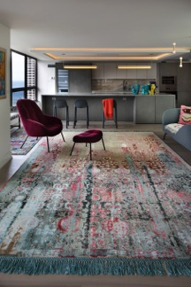
Now for the 15th time, the Carpet Design Awards at DOMOTEX will highlight the superior quality and outstanding design of the finest hand-made carpets and rugs. A jury of international experts, chaired by Graham Head, Vice Chairman of ABC Carpet & Home in New York City, will select the winners of these world-renowned awards in eight categories. The selection criteria are exceptional design, top quality and skilled craftsmanship. The winners of the international competition will be ceremoniously announced at the dedicated Carpet Design Awards display in Hall 3, Stand H23 at 6 p.m. on Saturday, 11 January 2020. “There were a great many entries this year, and I was impressed by quite a number of them,” remarked jury member Stefan Amstad, Category Manager Carpets at furniture giant Möbel Pfister. “I was delighted to see a wide variety of designs, with Bauhaus and Art Deco being the main influences.” Jury chairman Graham Head praised the “unique and innovative inspiring concepts” among the entries, “something in the fabric and texture of the carpet which has never been seen before.” The prestigious awards reflect the

industry’s innovative strength and trends. Since the start of the competition, the categories have been constantly revised and updated in line with the latest industry trends. Highlights of all nominated carpets and rugs will be showcased in the special display in Hall 3 throughout the run of DOMOTEX.

A list of nominees for the Carpet Design Awards can be found in the appendix.

Award for exemplary dealers

On Friday at 6 p.m. the Carpet Star Award will be presented to outstanding retailers who have demonstrated excellence in the carpet and rug business. This award winners from DOMOTEX 2019 were Lila Valadan (Lila Valadan, Hamburg) in the Exemplary Customer Event category, Reza Ashtari and Wendy Guns (Ashtari Carpets, Antwerp) in the Exemplary Website category, Möbel Pfister in the Exemplary Carpet Department category, Roz Rustigian (Rustigian Rugs, Rhode Island, USA) in the Exemplary Rug Specialist Shop category and Edi Kistler for his lifetime achievements. The award ceremony will be held in the special display of Hall 3, Stand H23.

An imaginative journey into Persian culture


The eponymous label created by German/Persian designer Lila Valadan is a striking mix of traditional and contemporary. Each of her rugs is a remarkable unique piece inspired by exceptional nomadic craftsmanship. As the creative mind behind the company Naziri, Lila Valadan has been a major name in the carpet world for many years and has won numerous awards in design competitions. The design of her rugs, which are appreciated by enthusiasts and collectors worldwide, is noble and elegant, modern and yet timeless. Lila Valadan offers a new take on old designs without denying their roots. This results in beautiful hand-made pieces such as the collections in The Four Seasons exhibition. Thanks to their high quality and design standards, they create a feeling of well-being and will be showcased at DOMOTEX 2020 in the form of a captivating presentation.

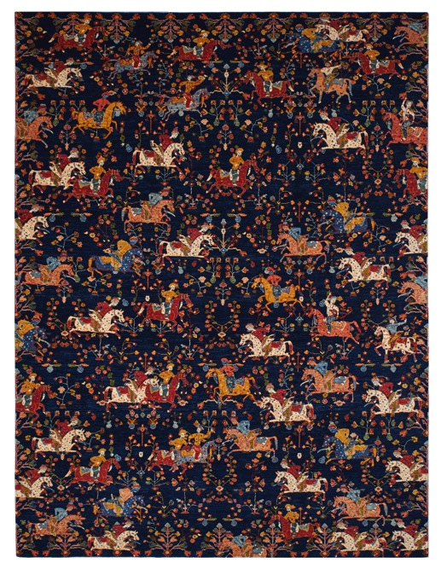
Visitors are invited to pass through a labyrinth of rooms in order to experience the unique characteristics of the four collections “Minimalism”, “Geometry”, “Floral” and “Untitled”. Each of the room installations is different from the previous and allows the observer to experience the fascinating interplay of light, textiles, sound elements and interior design, which draws on Persian culture.

Talks on today’s hottest topics

From Friday through Sunday, the Carpet Design Awards Talks program in Hall 3, Stand H23 will give visitors the opportunity to attend presentations covering topics of current and future interest. There will be two presentations daily – one each morning and one each afternoon – with each talk being followed by a panel discussion. Participants in the discussions will include well-known and highly renowned experts in the field of hand-made carpets and rugs. The talks will kick off at 11 a.m. on Friday with the Cover Talks@DOMOTEX presentation by Lucy Upward, editor of COVER Magazine, on the topic of ‘Rethinking the Rug: New methods for the rug industry’. Blogger Michael Christie from The Ruggist will then talk about a new method of carpet production using recycled nylon fibers. In addition, social responsibility label GoodWeave has invited a panel of experts to discuss how importers, producers, designers and other industry experts are creating transparent supply chains and tackling child and forced labor at all stages of production.

The precise times and titles of the talks can be found in the appendix.

From 10 to 13 January, international exhibitors and visitors will meet in the redesigned special display area (which boasts its own stage and café) for inspiration, comparing notes on presentations and pursuing new business interests.

Press contact:  neumann communication  Stephanie Klein, Hannah Knospe  and Ina Ehrlich  Tel.: +49 (0) 221 913949-0  E-Mail: domotex@neumann-communication.de | Contact for organizational matters:  Marketing & Communications  Anna Gerhard  Tel.: +49 (0) 511 8931603  E-Mail: anna.gerhard@messe.de

Appendix:

Nominees for the Carpet Design Awards 2020

Category 1: Best Studio Artist Design
Original small-scale production design by an artist or designer:
Floor_Story, Giovanni
Borderline Studio, The Inverted Reality
Michelle Mohr, Indigo Flow

Category 2: Best Modern Design Superior
Contemporary design showing optimum use of materials:
Kirkit Rugs, Full Moon and Dark Moon
Choudhary Exports, Shibuya
Jaipur Rugs, Stairmaze
Art Palace Export, Elbrus

Category 3: Best Modern Design Deluxe
Contemporary design showing optimum use of materials:
Wool & Silk, Fusion
Theo Keller, The Diamond
RUG STAR by Jürgen Dahlmanns, EasyMe No. 01, Original
Jaipur Rugs, Strati
Wool & Silk, Skydance

Category 4: Best Transitional Design
A new rug that interprets traditional designs for a contemporary audience:
Wool & Silk, Holi and Wild Pomegranate
RUG STAR by Jürgen Dahlmanns, NewTribal No. 09, Original
Lila Valadan, Shehnameh
Theo Keller, Mir New Chapter

Category 5: Best Flatweave Design
Original rug design demonstrating the flatweave technique:
Kirkit Rugs, Purple Abrash
Zollanvari International, After Navajo via Bauhaus Baneh and Eye Dazzler Baneh
Lila Valadan, Sixth Sense
Art India, Pranavi

Category 6: Best Collection
Contemporary traditional or transitional design collection demonstrating a common theme:
Kirkit Rugs, Moon Shadow, Moon Collection
Zollanvari International, Sunrise, Gashgha’i meets Bauhaus Collection
Jaipur Rugs, Pink Building, Jaipur Wunderkammer Collection
RUG STAR by Jürgen Dahlmanns, EasyMe No. 07, Original, EasyMe Collection
Wool & Silk, Folk, Rhythm Collection

Category 7: Best Interior
A high-end customization project or rug installation documented by high-quality photos:
RUG STAR by Jürgen Dahlmanns, Home Dana
Wool & Silk, Florence
Luz Mendez, Mount Fuji on Explosion
Category 8: Best Modern Design Select
Contemporary design showing optimum use of materials:
Deirdre Dyson, Plumes
Knots Rugs, Fresco
cc-tapis, Feathers Collection

Program for the Carpet Design Awards Talks

Friday, 10 January, 11 a.m.
CoverTalks @ DOMOTEX: “Rethinking the Rug: New methods for the rug industry – Part 1"
Lucy Upward, Editor of COVER Magazine

Friday, 10 January, 2 p.m.
“The Making of an ECONYL® Handknotted Carpet”
Michael Christie, The Ruggist (moderator) and participants from Aquafil and Sarawagi Rugs

Saturday, 11 January, 11 a.m.
CoverTalks @ DOMOTEX: “Rethinking the Rug: Voices from the industry –Part 2”
Panel discussion, moderation
Lucy Upward, Editor of COVER Magazine

Saturday, 11 January, 3 p.m.
CoverTalks @ DOMOTEX: “The Persian Carpet: Continuing Traditions”
Ben Evans, Editor and Director of HALI Publications

Sunday, 12 January, 11 a.m.
“Hidden Supply Chains and Human Rights: How carpet and home textile companies can improve rights for workers”
Panel discussion initiated by GoodWeave

Sunday, 12 January, 3 p.m.
“The Showroom of the Future (TSOFT)”
Presentation by Michael Christie, The Ruggist

